# CS 340 README

## About the Project/Project Title

The current project was given to Global Rain by Grazioso Salvare. They had asked our team to develop an application that would assist in finding the right dogs to train for the right job. One important thing the client had asked of us was to allow the code to be open source on GitHub. This means that all code must be reusable and accessible to everyone. This will allow a user to look through different shelters database’s information to look for certain traits. The system uses a PyMongo driver within MongoDB to read a Python file. The PyMongo driver was chosen due to the client wanting the code to be reusable. A py file that contains all the necessary methods for the functionality will be read in. The py file contains a class that allows creating, reading, updating, and deleting from the database. These 4 methods are the core to CRUD.

For ease of use, the application will have a dashboard to see what dogs are the best suited visually. The dashboard consists of a table with information on the dogs contained in the database. This table can be filtered using a drop-down menu on what job needs a dog. For instance, if the job in need is for “Water Rescue” then it will filter dogs that match the criteria for “Water Rescue”. Under the table, there is also a graph and a geolocation map. The graph shows the dogs by breed after being filtered. The geolocation map shows the location of the highlighted row location, with a pinned location based on the latitude and longitude data for the given dog. For the components in this application to work we had to integrate a few libraries. Most of this was brought in from Python’s dash components. (<https://dash.plotly.com/>).

The completion of this project had many steps. Many of which had their challenges. It Started with creating the database and creating an authorized user for that database. Databases are rather new for me, and everything I’m learning is from scratch. The understanding of how everything works together took quite some time. After the database, I created a Python file that held the CRUD methods for the functionality of the database. The hardest part of creating the Python file was the fact that I only used Python once in my coding career and it took some time to remember the syntax in order to write it the correct way. When the database functionality was completed, the dashboard became the next objective. The dashboard was built for a visual purpose for the application for the client to use. It shows the data from the database based on what the client needs in easy-to-read visual detail. With the dashboard, I had lots of challenges. My biggest problem was getting my callbacks to work properly. After fighting with it for days I finally got the filtering to work properly and the callbacks went away. The drop-down menu allows the client to choose from 3 different rescue types. It sorts through the database to show only dogs that work for the rescue type based on the traits the client originally gave in to work with.

## Motivation

Not every dog has the right characteristics for every job. There must be some sort of system that can help find the specific traits that are wanted in a dog for training. This system will read the data and print a list of the dogs that fit the correct profile. The software being used was chosen because of its unique capabilities to query through the database and efficiently use the functions.

## Getting Started

For someone to use this system the following steps would need to be implemented:

* The database being used must be imported. This can be done with the data on a CSV file. It will contain all info and traits on the different items in the database. For this particular project we used the aac_shelter_outcomes.csv and it would be imported the follow way in Linux

mongoimport --username="${MONGO_USER}" \

--password="${MONGO_PASS}" --port=${MONGO_PORT} \

--host=${MONGO_HOST} --db=AAC --collection=animals \

--authenticationDatabase admin \

--file= /usr/local/datasets/aac_shelter_outcomes.csv \

--type csv --headerline

* To read through the database, we need to parse through the different items. We do this by creating an index. In our project one example we used to parse through was the findOne() in the mongo shell.

db.animals.findOne()

* A user needs to be created besides the admin, to be given the rights of functionality that the system will use. For this assignment, we used the “C” and “R” of CRUD. (Create and Read)

Done in mongo shell

db.createUser({ user: "aacuser", pwd: "SNHU1234", roles: [{ role: "readWrite", db: "AAC"}]})

Then it must be authenticated

Done in Linux

MONGO_USER=aacuser

MONGO_PASS=SNHU1234

printenv | grep -i mongo

* A py file must be created that contains the methods that will be used (methods for create and read)

*Py file example in the screenshot section of this document*

## Installation

You will need to install the following:

* The Newest Version of Jupiter Notebook
* The Newest Version of Python*.*
* The Newest Version of MongoDB.

## Usage

The system’s usage is for the purpose of CRUD methods. We currently can create data into a database, and read through the to find certain traits within that database. Later on update and delete will also be implemented

### Code Example

*Import the MongoClient*

from pymongo import MongoClient

from bson.objectid import ObjectId

class AnimalShelter(object):

def __init__(self):

USER = 'aacuser'

PASS = 'SNHU123'

HOST = 'nv-desktop-services.apporto.com'

PORT = 30056

DB = 'AAC'

COL = 'animals'

self.client = MongoClient('mongodb://%s:%s@%s:%d' % (USER,PASS,HOST,PORT))

self.database = self.client['%s' % (DB)]

self.collection = self.database['%s' % (COL)]

*A Create Method for new data*

def create(self, data):

if data is not None:#if not null

try:

createData = self.database.animals.insert_one(data)# try/catch if data in dictionary

return True#if complete return true

except Exception:

return False#if exception return false

else:

raise Exception("Nothing to save, because data parameter is empty")#if null/none

*A Read Method*

def read(self, data):

if data is not None:#if not null/none

readData = self.database.animals.find(data)#find/read data

else:

raise Exception("Nothing to save, because data parameter is empty")#else exception if null/none

return readData#return readData if not empty

*An Update Method*

def update(self, read, data):

if data is not None:

updateData = self.database.animals.update_many(read, {"$set": data})

return updateData.modified_count

else:

raise Exception("Nothing to save, because data parameter is empty")

*A Delete Method*

def delete(self, data):

if data is not None:

deletedData = self.database.animals.delete_many(data)

return deletedData.deleted_count

else:

raise Exception("Nothing to save, because data parameter is empty")

### Tests

Tests were used for multiple cases of this project. We tested that the create method would successfully create new data for the database. We would store this new data in a variable and validate that the variable in not empty. The test would output True if it succeeds. After it succeeds, create is used with “None” as the parameter to validate that it would throw an exception. The next test sends the variable used previously to make sure a duplicate can not be made. This test should then output False. The following test is conducted to test the read function and validate that the new data added to the database, can be found. To continue testing the read function, I tried to find a name not contained in the database. Since this name is not in the database the output would be an empty list designated by []. The next test is to validate that if None is given as a parameter for the read function, it would throw an exception. Some examples of all these tests are shown in the following screenshots.

The next couple of tests are used to show that the update works. I chose to update the dog I had previously created since screenshots show the ID number. This method will also display a number that will signify how many items were changed with the update. After updating the name of the dog, I created I called to read method again to prove that that ID now contained the new name. Once I knew the method worked, I moved on to test the exception and sent in “None” as the parameter, which did correctly throw an exception. Following the update method we tested the delete method. First, I tested it to delete animal_type “Cat”. The output shows how many of those items were deleted. Just like the previous methods, I also used “None” as a parameter as and checked that it threw an exception. This worked correctly, and as the final test, I tried to delete animal_Type “Cat” again. When the output returned zero that proved there were no cats left to be deleted and that the first delete test worked as it should of.

### Screenshots

Imports the csv file into the database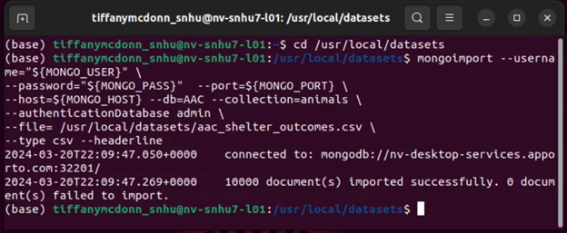

Logging in as the created user

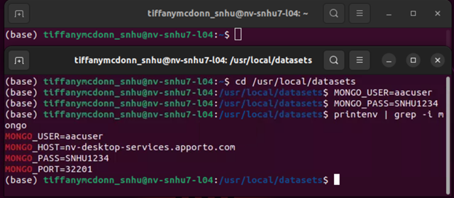

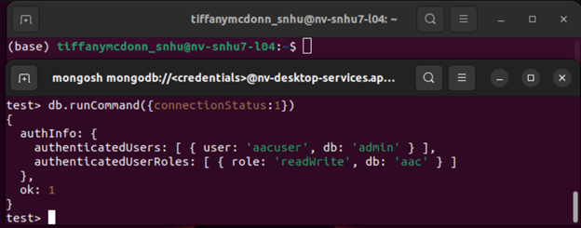

Import the MongoClient in the py file

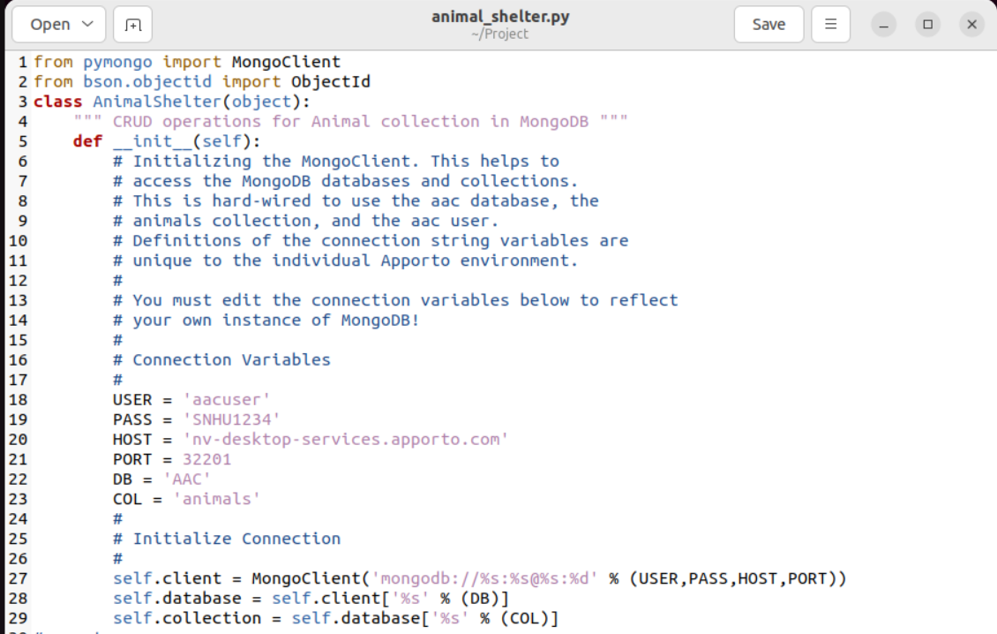

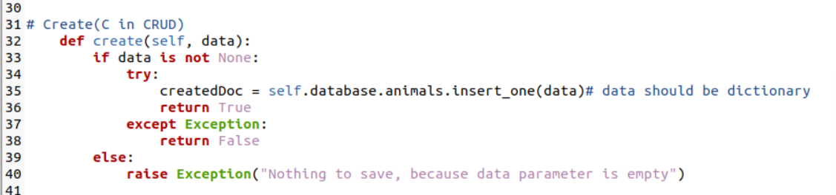

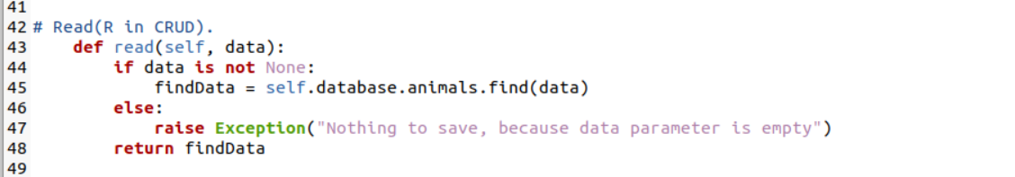

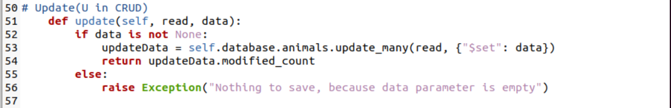

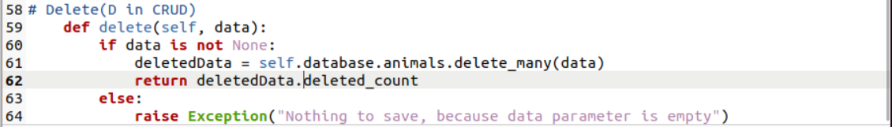

Proceed with all necessary tests

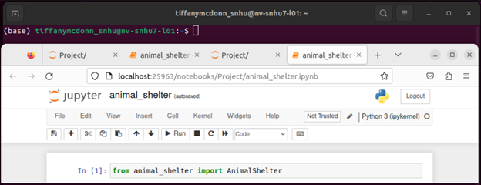

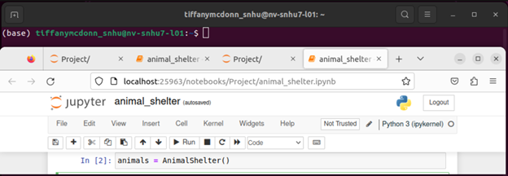

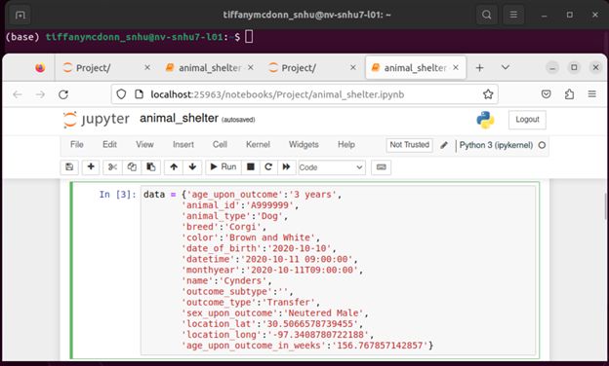

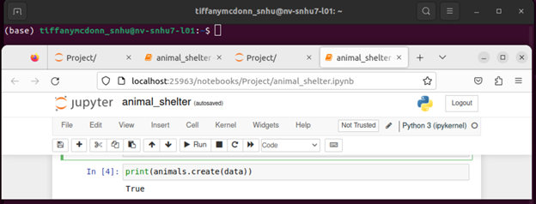

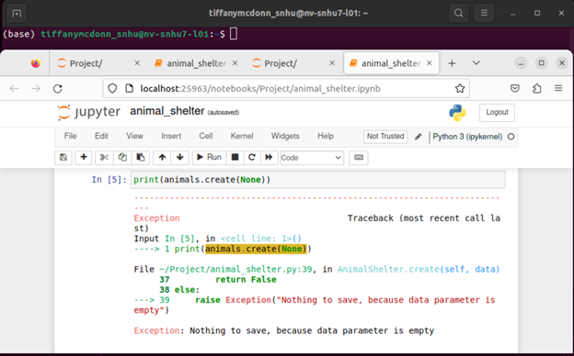

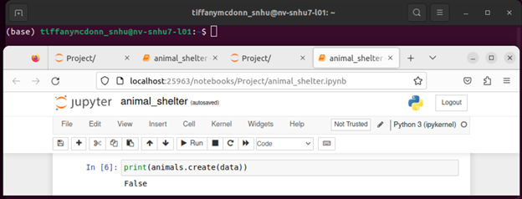

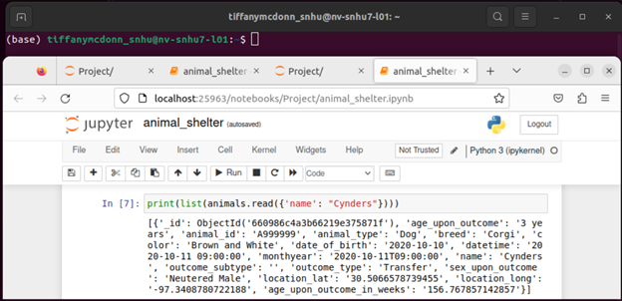

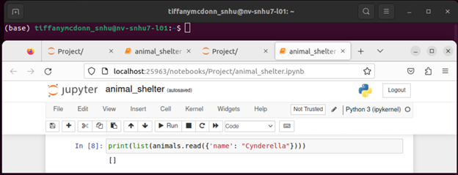

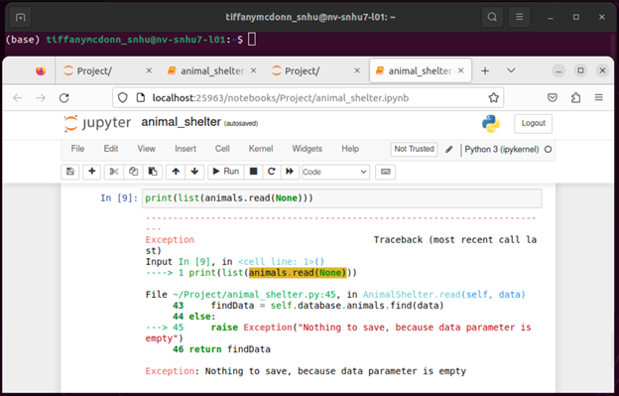

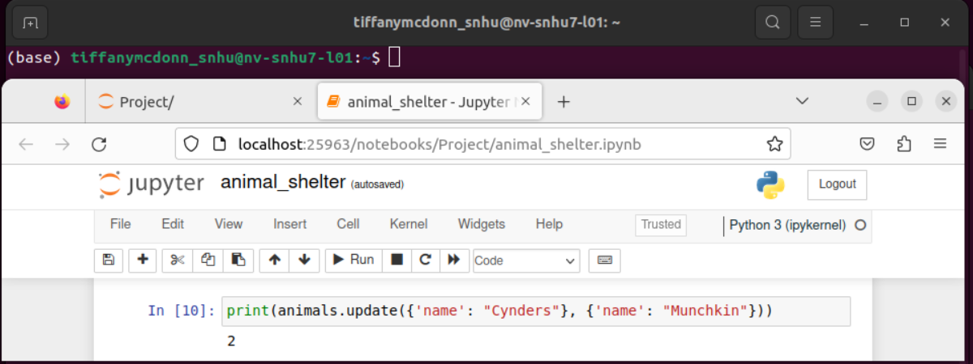

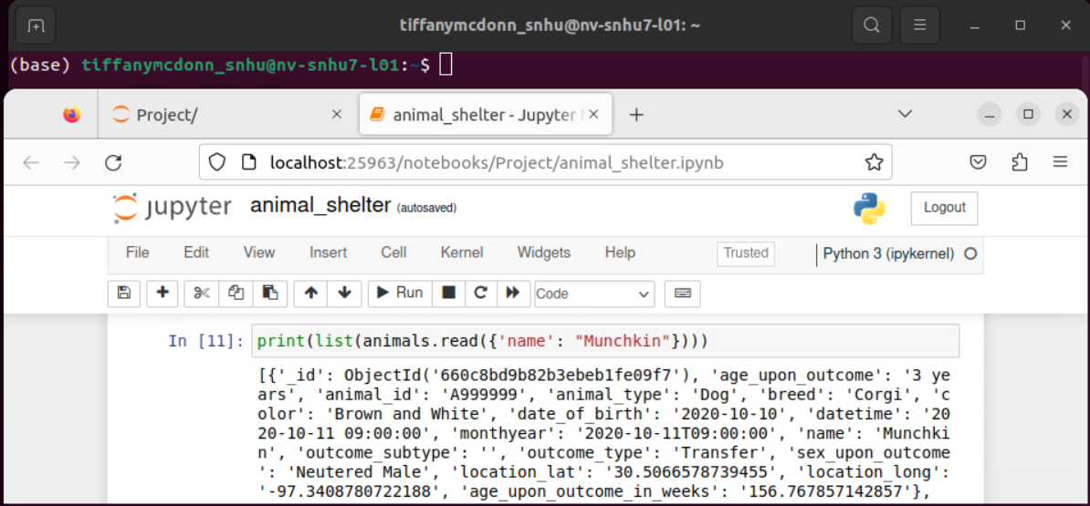



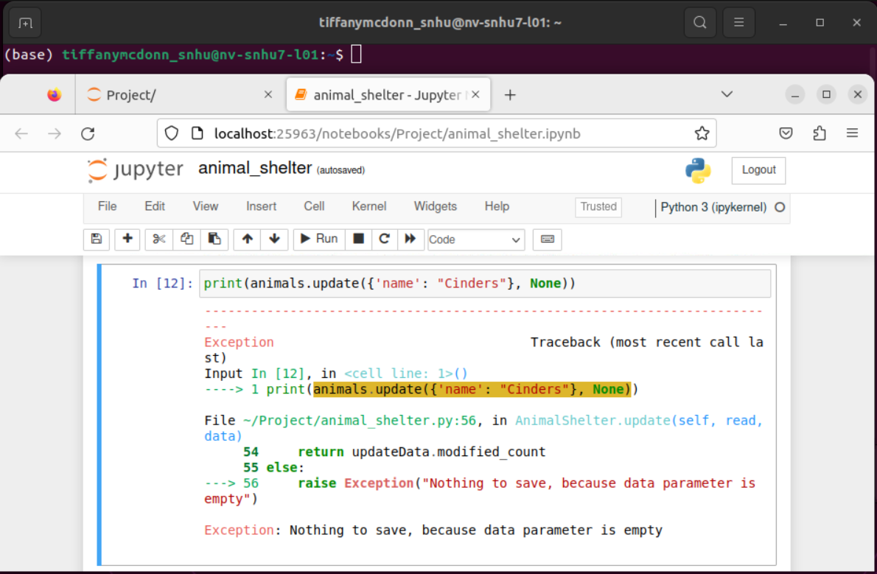

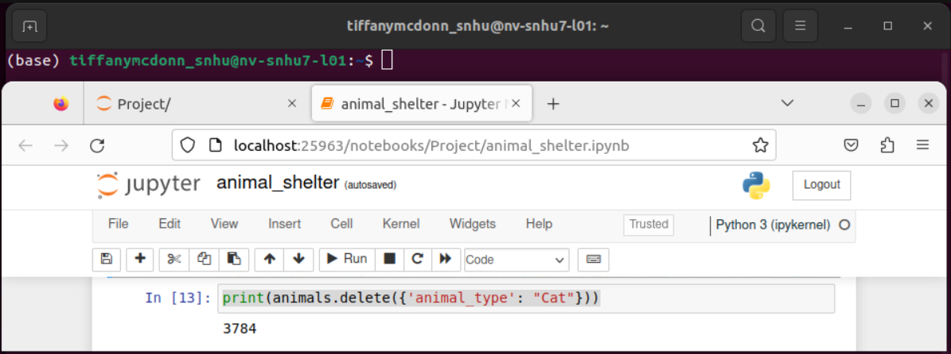

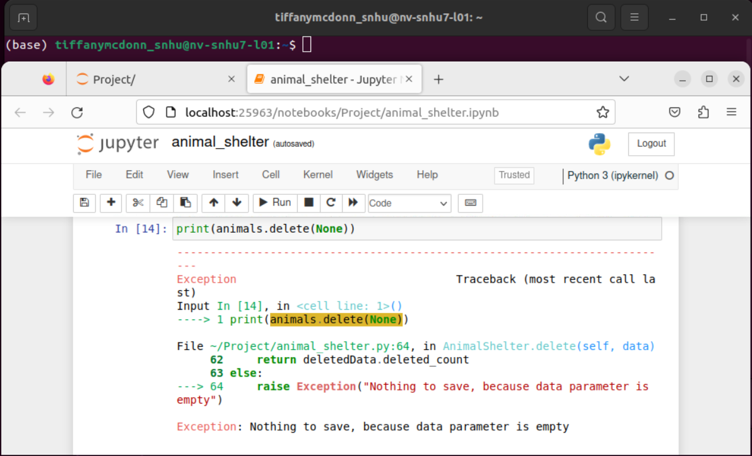

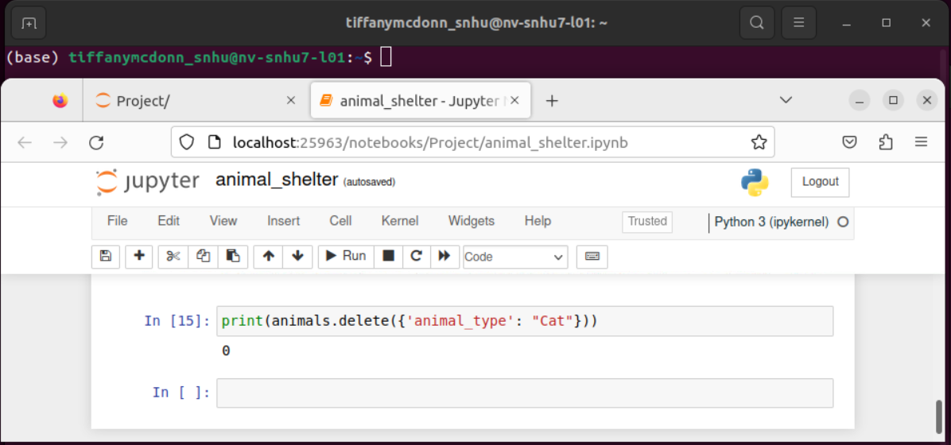

Query filters

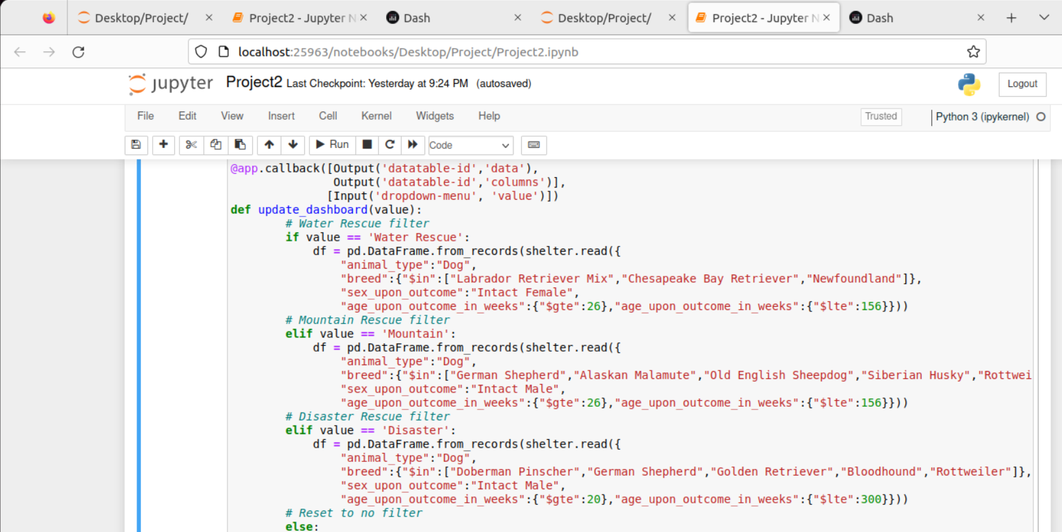

Final Result before the filter is applied

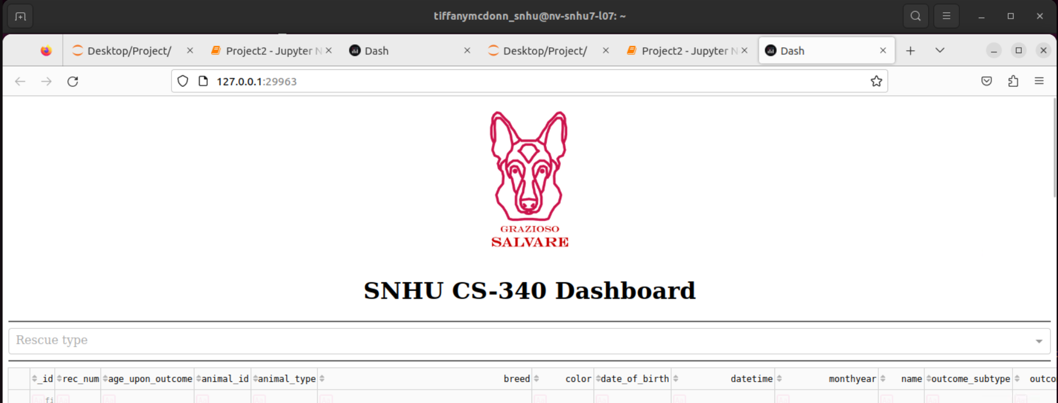

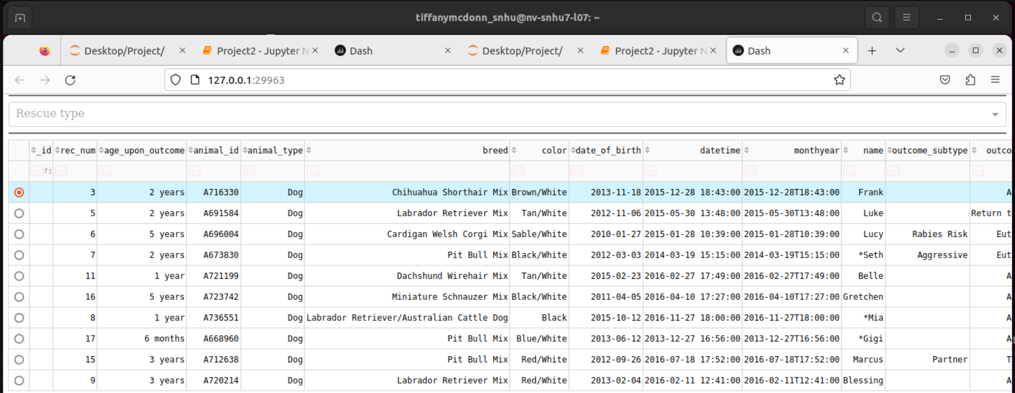

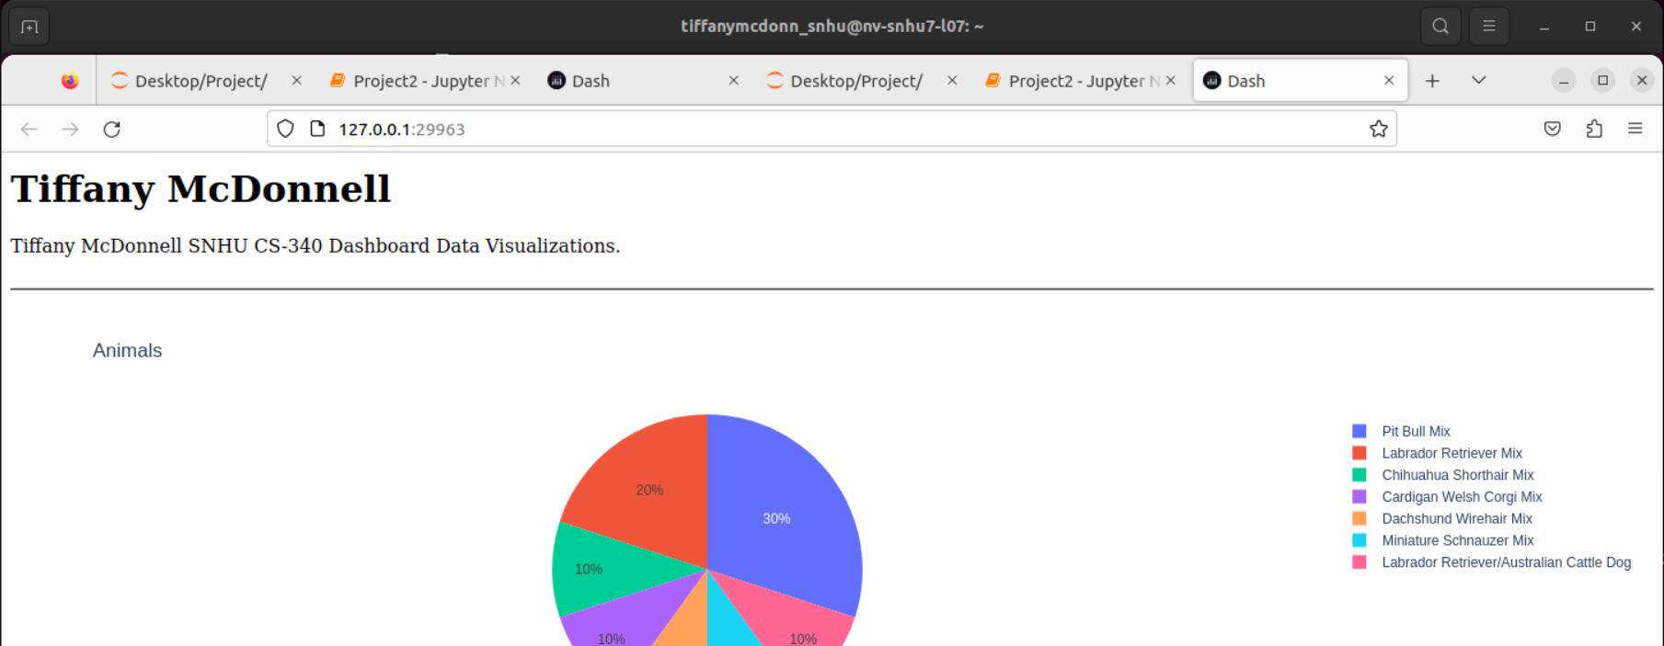

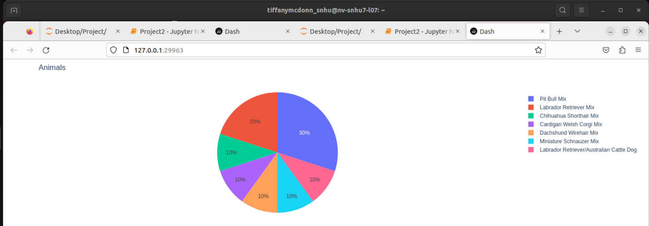

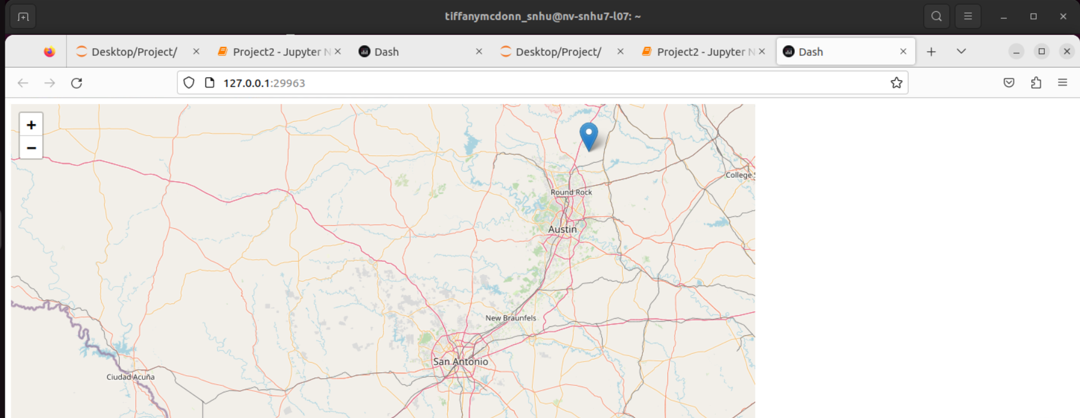

Final Result after Water Rescue is applied

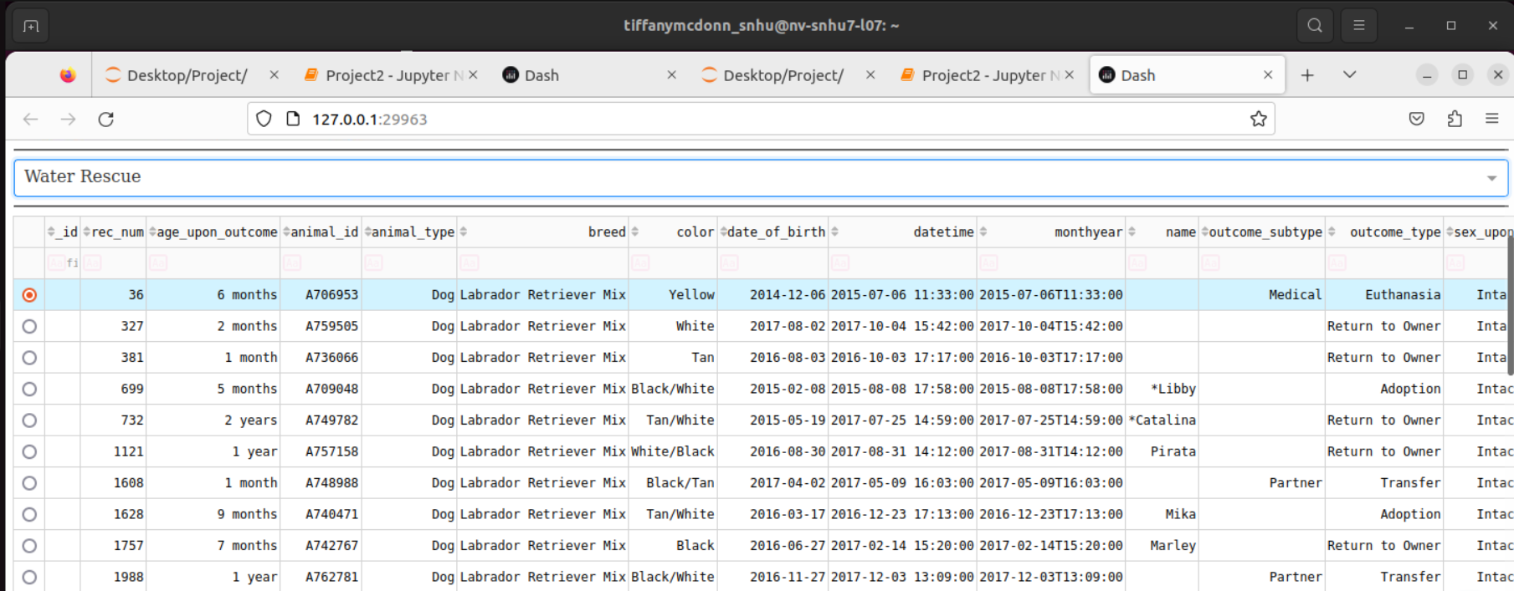

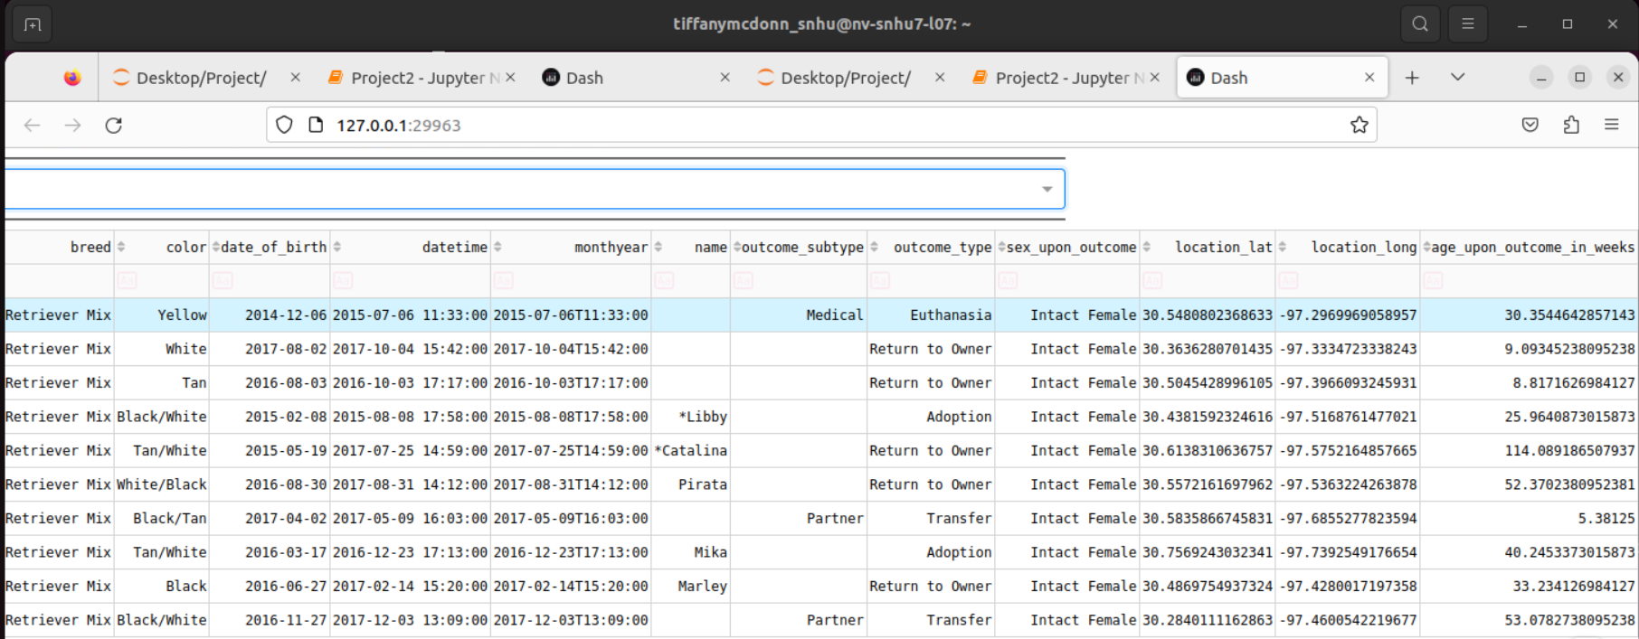

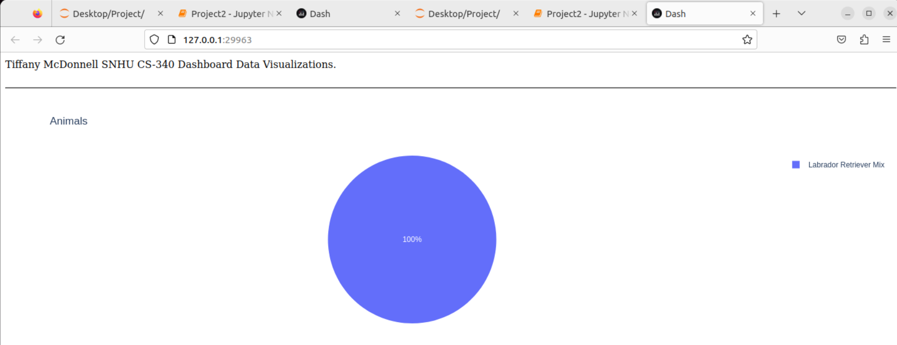

Final Result after Wilderness and Mountain Rescue

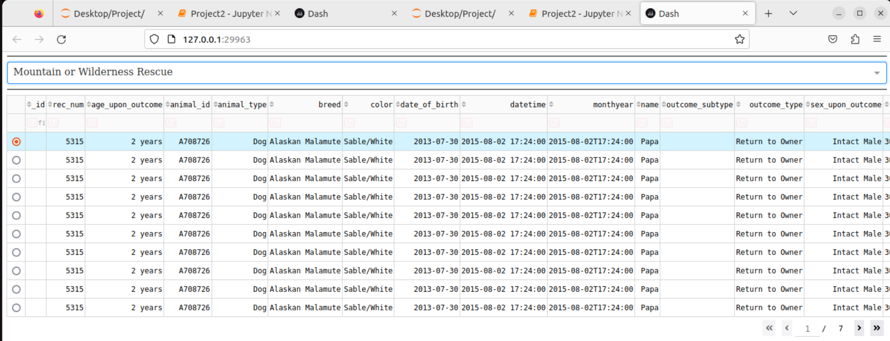

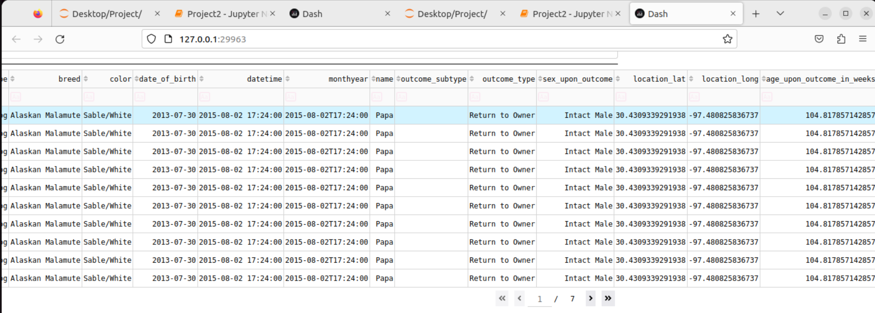

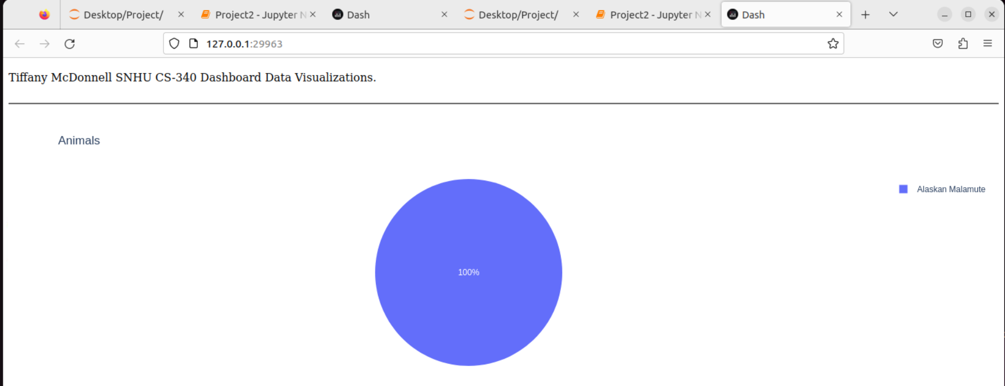

Final Result after Disaster Rescue is applied

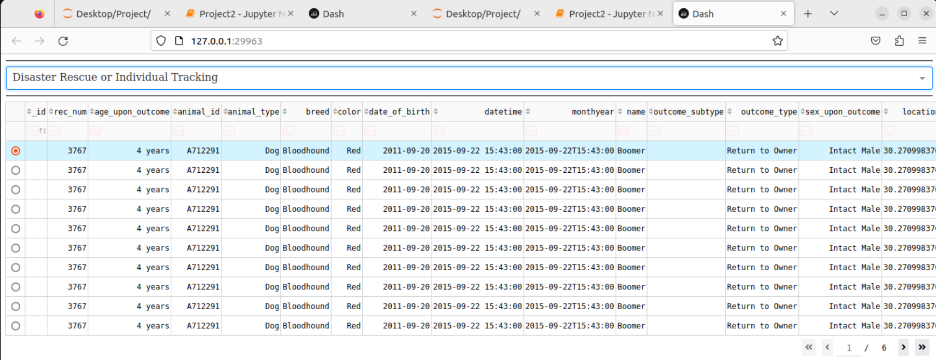

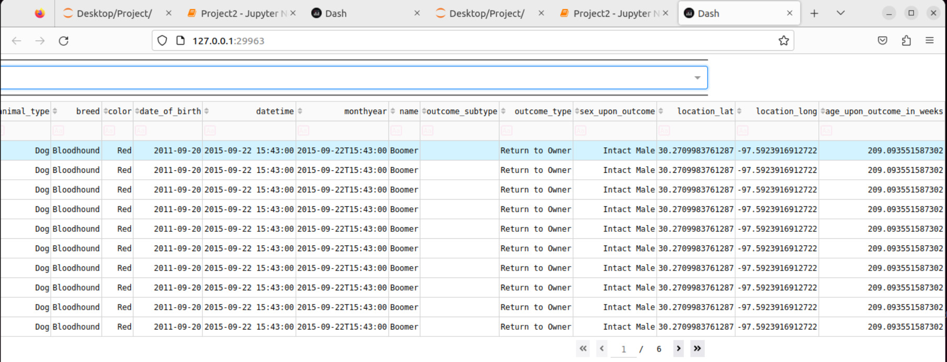

Proof of pie chart adjusting based on table

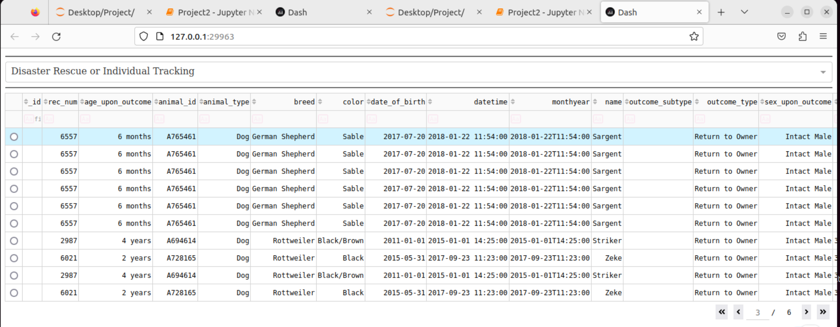

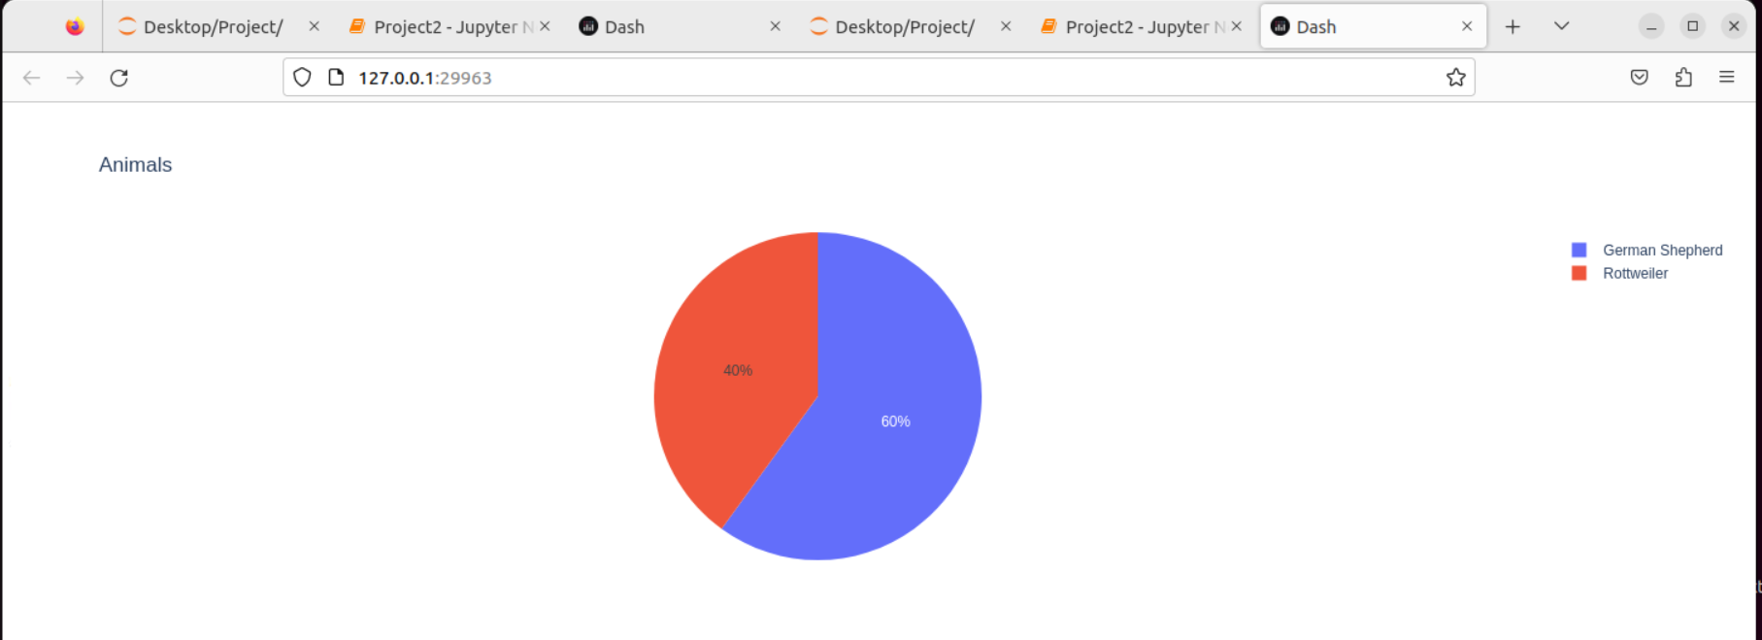

Rows are selectable

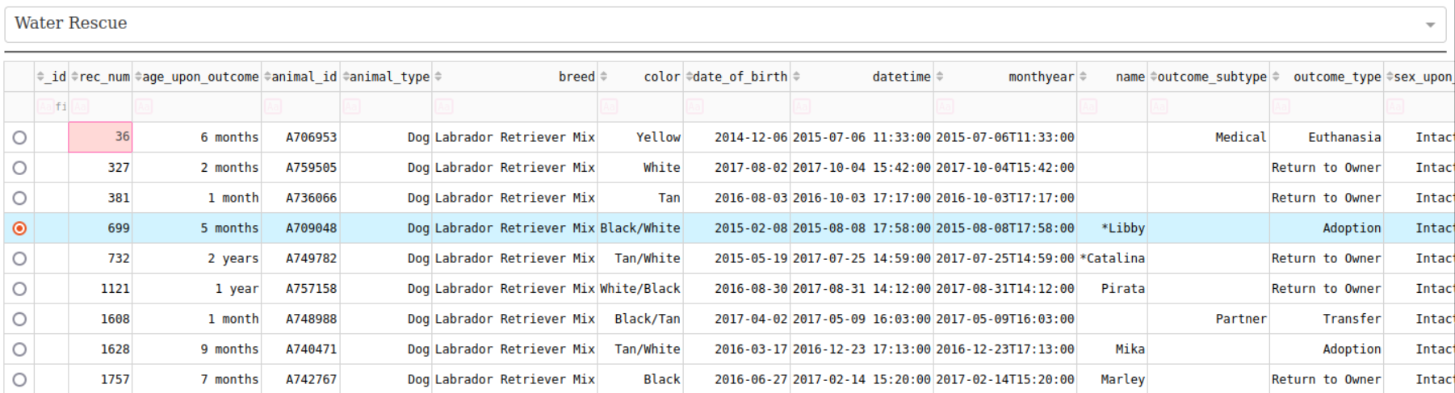

Mouse over a section in the pie chart shows breed

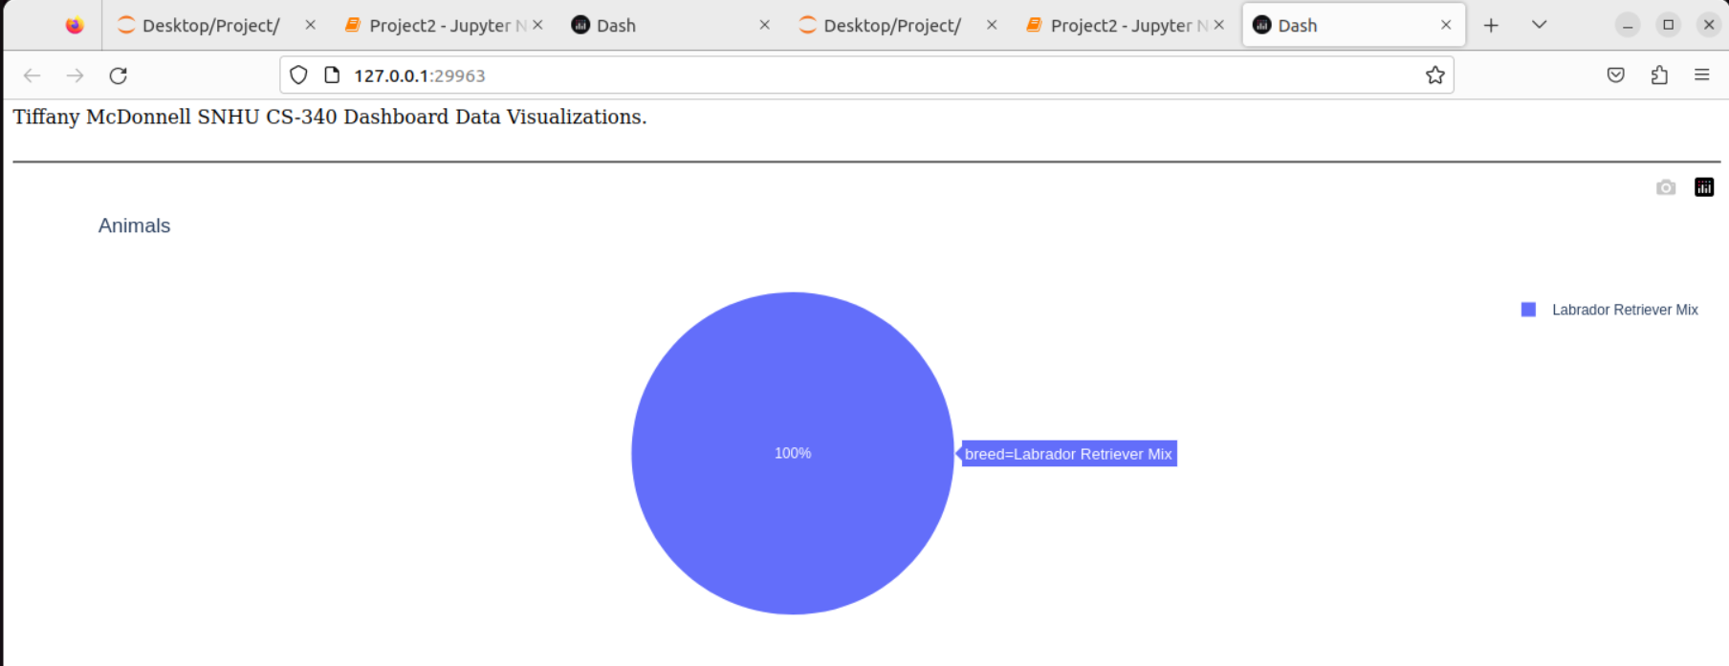

Mouse over pointer in map shows what dog is at that location

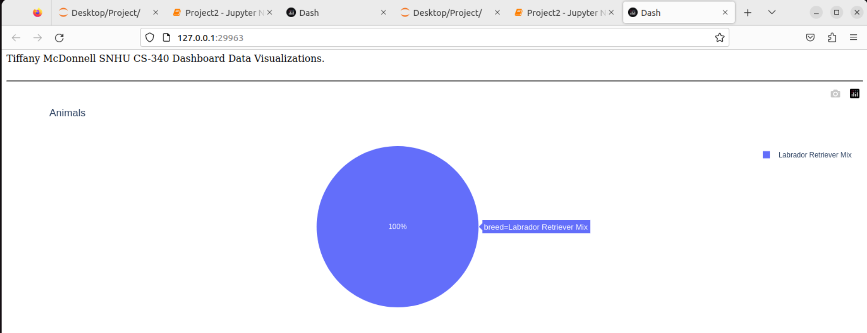

## Contact

Tiffany McDonnell